|  |  |
| --- | --- |
| **Name** | Urwa Maryam |
| **Roll no.** | 352 |

**LAB 3**

**Introduction to palindrome number and while and for loop**

**Objectives:**

* Use of if, else statement to check whether a number is palindrome or not.
* Use of while and for loop to count a number.
* Use of while and for loop to solve factorial of a number.
* Use of while and for loop to find multiples of a number.
* Using while and for loop to calculate the value of mathematical constant ‘e’.

**Task 1:**

Palindrome is a five-digit number that reads the same backward as forward e.g. 12321, 33333 etc. Implement a program that takes a five-digit no. from user and determine whether it is a palindrome or not.

**Code:**

a=int(input(“enter a number”))

b=a%10

c=int(a/10)

d=c%10

e=int(c/10)

f=e%10

g=int(e/10)

h=g%10

i=int(g/10)

if(h==b and d==i):

print(“a is a palindrome”)

else:

print(“a is not a palindrome”)

**Output:**

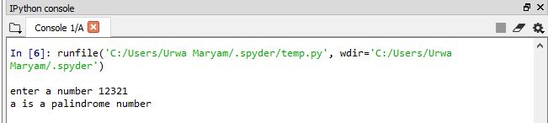

Figure no. 3.1: Output of task 1.

**Task 2:**

Implement a program that takes 10 integers from user. Implement a program that will count the number of times user enter integer ‘2’. Also display the count on output screen. Implement using both for and while loop.

**Code:**

“““Using while loop”””

count=0

counter=10

while(counter>0 and counter<=10):

a=int(input(“enter a number a=”))

counter -=1

if(a==2):

count += 1

print(“number of times the user enter 2 is”, count)

“““Using for loop”””

count=0

for i in range(10):

a=int(input(“enter a number a=”))

if(a==2):

count += 1

print(“number of times the user enter 2”, count)

**Output:**

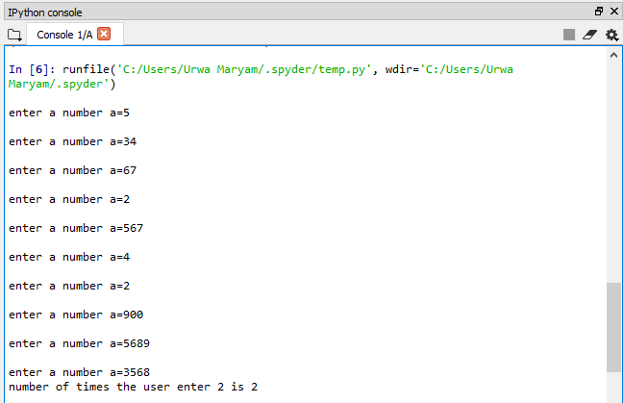

Figure no. 3.2(a): Output of task 2 with while loop.

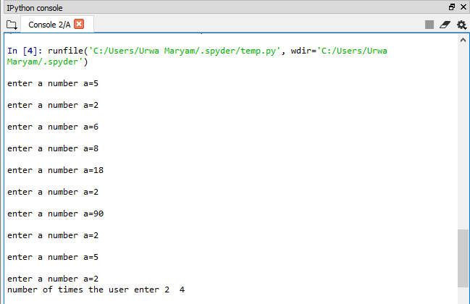

Figure no. 3.2(b): Output of task 2 with for loop.

**Task 3:**

Implement a program that prints multiple of 5 in range defined by user such that only 5 multiples are printed in a row. Implement using both while and for loop.

**Code:**

“““Using while loop”””

a=int(input(“provide a lower limit”))

b=int(input(“provide an upper limit”))

count=0

c=a

while(c<b):

if(c%5==0):

print(c,end=‘\t’)

count+=1

if(count==5):

count=0

print(“\n”)

c+=1

“““Using for loop”””

a=int(input("provide a lower limit"))

b=int(input("provide an upper limit"))

count=0

for i in range(a,b):

if(i%5==0):

print(i, end=‘\t’)

count+=1

if(count==5):

count=0

print("\n")

i+=1

**Output:**

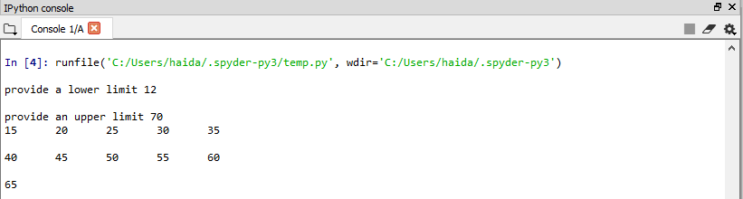

Figure no. 3.3(a): Output of task 3 with while loop.

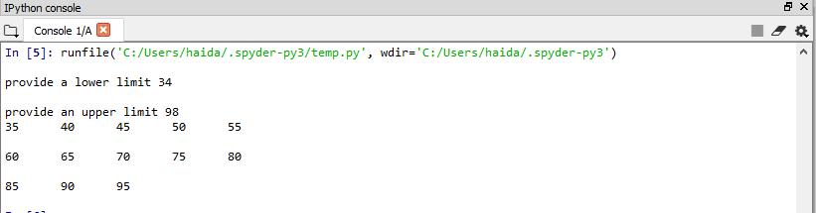

Figure no. 3.3(b): Output of task 3 with for loop.

**Task 4:**

Implement a program that takes a number from user and print its factorial. Apply both while and for loop.

**Code:**

“““Using while loop”””

a=int(input("enter a number"))

factorial=1

while(a>0):

factorial*=a

a-=1

print(factorial)

“““Using for loop”””

a=int(input("enter a number"))

factorial=1

for i in range(1,a+1,1):

factorial*=i

print(factorial)

**Output:**

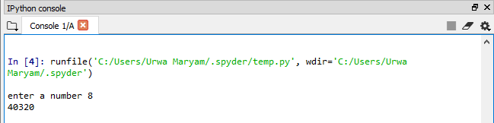

Figure no. 3.4(a): Output of task 4 with while loop.

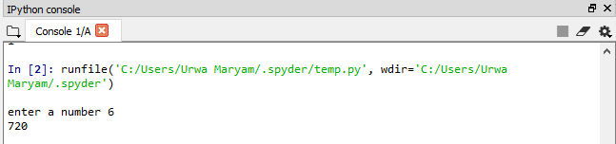

Figure no. 3.4(b): Output of task 4 with for loop.

**Task 5:**

Implement a program that evaluates the value of mathematical constant “e” .

e=1+1/1!+1/2!+1/3!+1/4!+…

Prompt the user to enter more number of terms for desired accuracy of value of e.

**Code:**

"""using while loop"""

a=int(input("print number of terms to be added"))

e=1

factorial=1

i=1

while(i<a):

factorial*=i

i+=1

e=e+1/factorial

print("the value of e upto given no. of terms is",e)

"""using for loop"""

a=int(input("print number of terms to be added"))

e=1

factorial=1

for i in range(1,a):

factorial*=i

e=e+1/factorial

print("the value of e upto given no. of terms is",e)

**Output:**

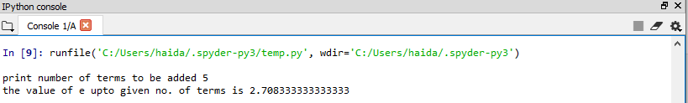

Figure no. 3.5(a): Output of task 5 with while loop

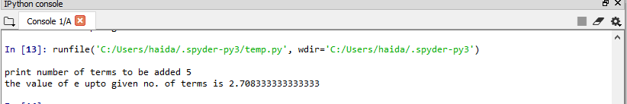

Figure no. 3.5(b): Output of task 5 with for loop

**Conclusion:**

Through this lab, I have learnt about how can I develop a program to show whether a five-digit number is palindrome or not. I have about **while loop** and **for loop** to find multiple of a number, to solve a factorial and to count a number. I have learnt how to solve the value of mathematical constant ‘e’.